Regular Expressions:

|  |  |
| --- | --- |
| **^** | Matches the beginning of a line |
| **$** | Matches the end of the line |
| **.** | Matches any character |
| **\s** | Matches whitespace |
| **\S** | Matches any non-whitespace character |
| **\*** | Repeats a character zero or more times |
| **\*?** | Repeats a character zero or more times (non-greedy) |
| **+** | Repeats a character one or more times |
| **+?** | Repeats a character one or more times (non-greedy) |
| **[aeiou]** | Matches a single character in the listed set |
| **[^XYZ]** | Matches a single character not in the listed set |
| **[a-z0-9]** | The set of characters can include a range |
| **(** | Indicates where string extraction is to start |
| **)** | Indicates where string extraction is to end |

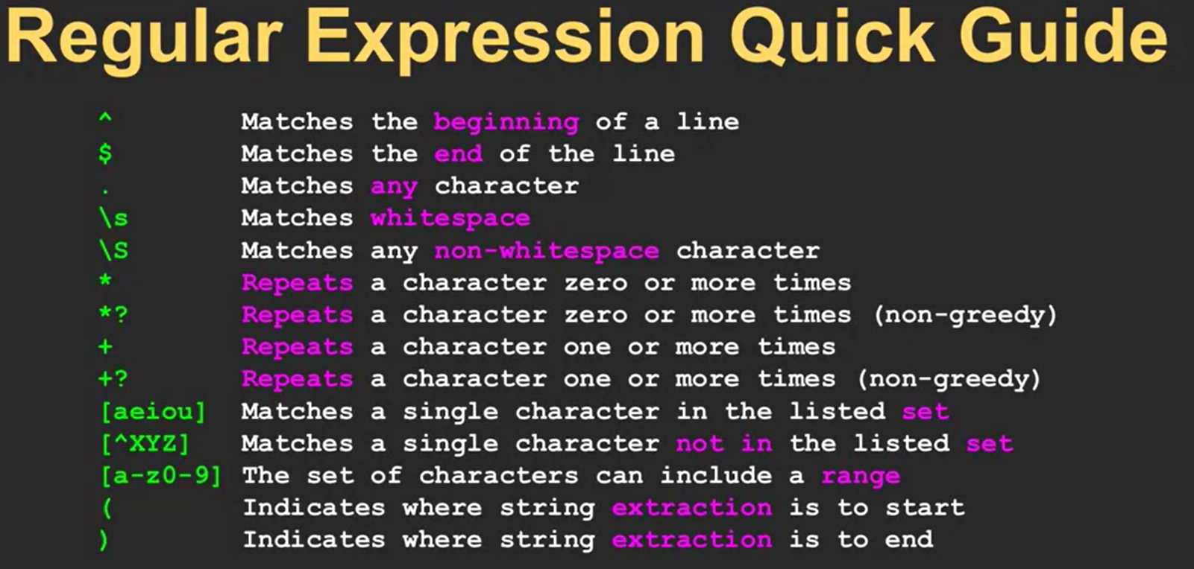

|  |  |
| --- | --- |
| **import re** | Library |
| **re.search()** | To see if a string matches a regular exp. |
| **re.findll()** | To extract portions of string that match your regular exp. |



